**Write all of the codes with python and send them to me by deadline.**

# 1-Write your name as a comment in python script.

# 2-Import the numpy submodule and name it np

# 3-Import the pandas submodule and name it pd

# 4-Import the matplotlib.pyplot submodule and name it plt

# 5-Ceate a list color including the name of 'm', 'k', 'y', 'b', 'r', 'gold', 'g', 'c', 'cyan', 'wheat': colors

# 6-Import summer_2016_medals CSV file as a DataFrame: summer_2016_medals.

# 7-Print information about summer_2016_medals.

# 8-Print a description of summer_2016_medals.

# 9-Print the shape of summer_2016_medals.

# 10- Convert the Age column into integer and save the result into a new column: Age_int.

# 11- Do you find any problem in Gender Column? you should clean inconsistency in order to have a column with two origin categories(Male, Female). In this way, you must use capitalize method. How? Please search on the Internet.

# 12- Convert data in Country column into two categories.

# 13- Find complete duplicate values then drop them.

# 14- Use asset to check your answers in question 10,11,12,13.

# 15-Print the five first rows of summer_2016_medals.

# 16-Collect the unique sport names in the Sport column and save them in 'group' variable. (Hint: use the set theory)

# 17-print the type of group

# 18-Create a list from group: sports

# 19-plot a horizontal bar chart by considering the following conditions:

# 19-1- Iterate over the values of sports as well as the colors list(question 5) and set sport and color as your loop variables.

# 19.2-In each iteration, extract the rows where the "Sport" column is equal to sport.

# 19.3-Call the ax.barh method then add a bar to the provided ax object, labeled with the sport name, with the mean of the "Weight" column.

# 19.4-Set the x-axis label to "weight".

# 19.5-Display the legend in upper wright.

# 19.6-Save the figure into the file "your name.pdf". Hint( use fig.savefig with bbox_inches argument equal to 'tight'. set dpi argument to 400)

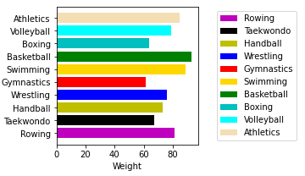

# 20-Create a tuple with 4 elements, including your name, your email address and your major.

use the print function only once to print each sentence in each line such as bellow:

My name is Ali Karami,

My email address is alikarami.kntu@gmail.com

I am M.S in civil engineering.